ME-Cylinder Seals

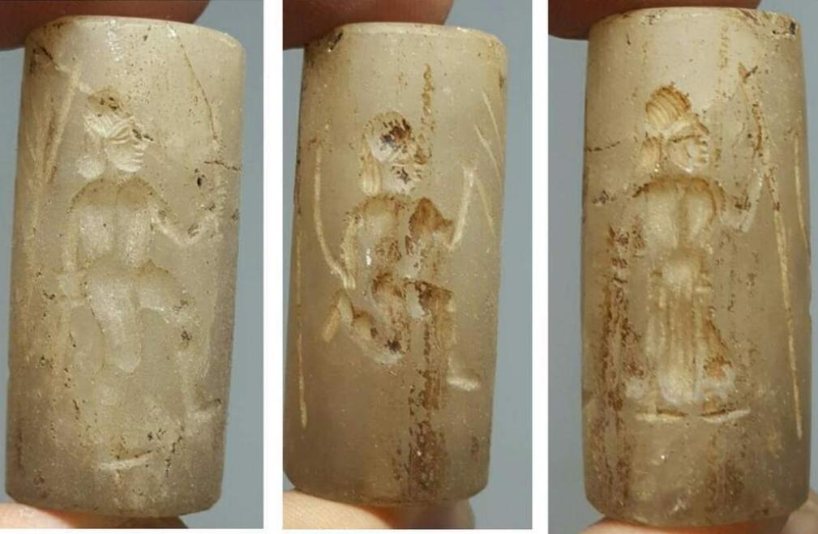 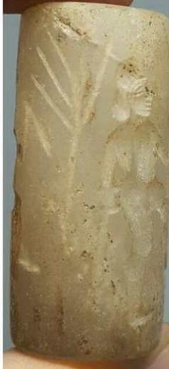

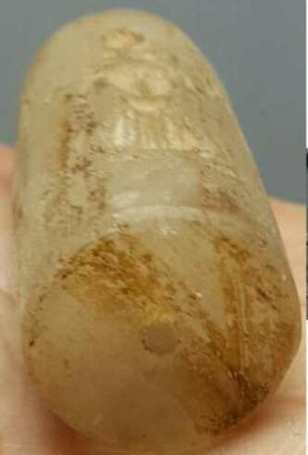 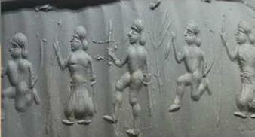

Formal Label:

Accession Number:

Date or Time Horizon:

Geographical Area:

Cultural Affiliation:

Media:

Dimensions:

Weight:

Condition:

Provenance:

**Discussion:**

**References**

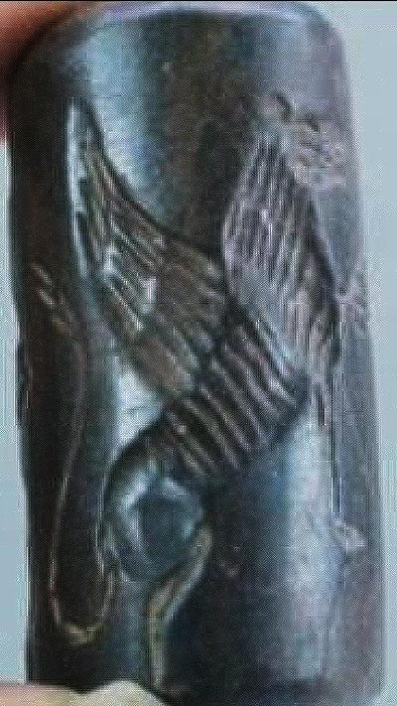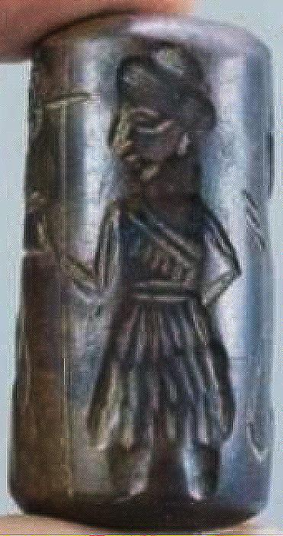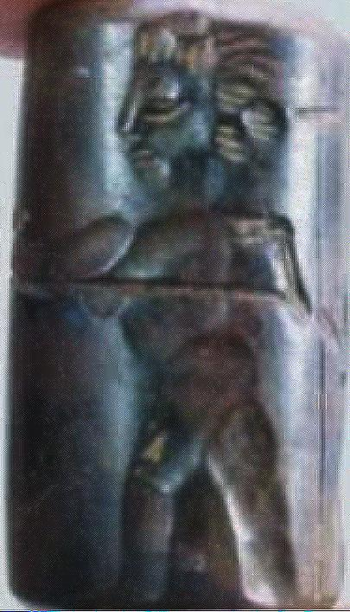

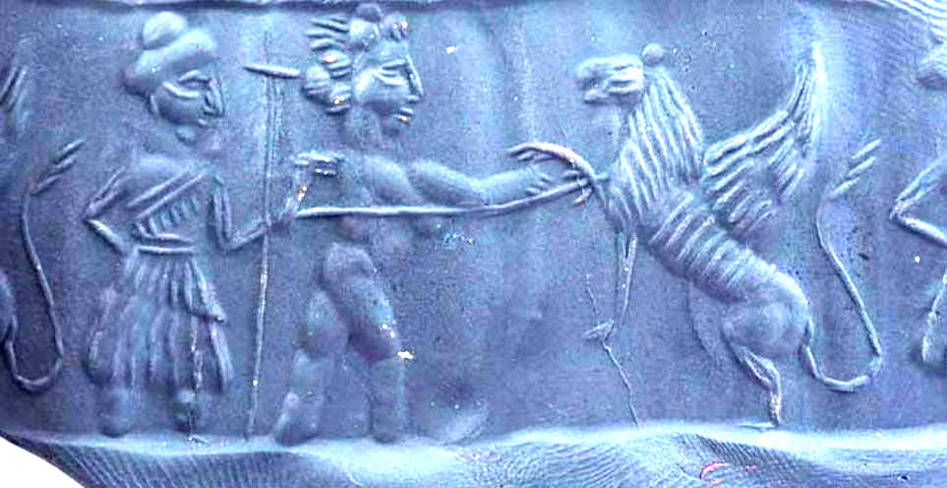

Formal Label: Cylinder seal and roll-out scene, Early Assyrian Period (**1350-1000 BCE**), showing an unknown king (identified by his attendant holding his royal standard) about to dispatch a mythic, winged, beaked raptor-Asian lion.

Accession Number:

Date or Time Horizon: 1350-1000 BCE, Early Assyrian Period

Geographical Area: Assyria

Medium: Jastbar Carnelian stone

Dimensions: L 3.4 cm

Weight:

Condition:

Provenance:

**Discussion: This** Early Assyrian Period (**1350-1000 BCE**) cylinder seal, showing an unknown king (identified by his attendant holding his royal standard) who is about to dispatch a mythic, winged, beaked raptor-Asian lion. As the king offers his extended and protected right hand he spears it with his left hand. His warrior attendant carries the king’s **standard. The king’s right arm is much larger than his left indicating that he has protected it by wrapping some protective covering around it such as “**a huge quantity of goats'-hair yarn or tent-cloth" (Reade 1998: 72-78)**. This is perhaps a unique scene,** since Henri Frankfor remarked that this padded defense, **which was the accepted practice of engaging lions,** was never depicted (Frankfort 1988)**. As the king would extend one arm towards the beast, his other arm would firmly grasp a weapon, such as a spear (in this case) or a sword, by which he could quickly dispatch the animal with a single thrust.**

**Beginning in this** Early Assyrian Period **symbolic** killing of lions was reserved for royalty with depictions of kings incorporated into art beginning with rare pieces such as this cylinder seal scene. A religious dimension to this ritualized sacrifice is clearly shown in later bas-reliefs where the lion is shown in great agony indicating that the action was both necessary and demanded for atoning of the animal’s nature. The lion may have been symbolic for the human enemy confronted in battle and its death may have been considered both horrific but necessary. This may be further supported by the fact that a surviving cuneiform indicates that when a lion was trapped in a provincial house, it must be delivered to the king. In fact, the number of lions killed in this royal ritual caused such an extensive depletion of the Asian lion that it is only found in a small population in India (Franckfort 1988: 187).

**This is an early version of what later became the winged lion that guarded the Sargonic entrances to palaces, fortresses and cities (such as those guarding the main entrance to Sargon’s Thone Room in his Palace at Khorsabad.**

**In the course of the centuries intervening between the depiction of this unknown Early Assyrian King and the Later Assyrian Period formal bas relief of** Assurbanipal killing a *lion*.

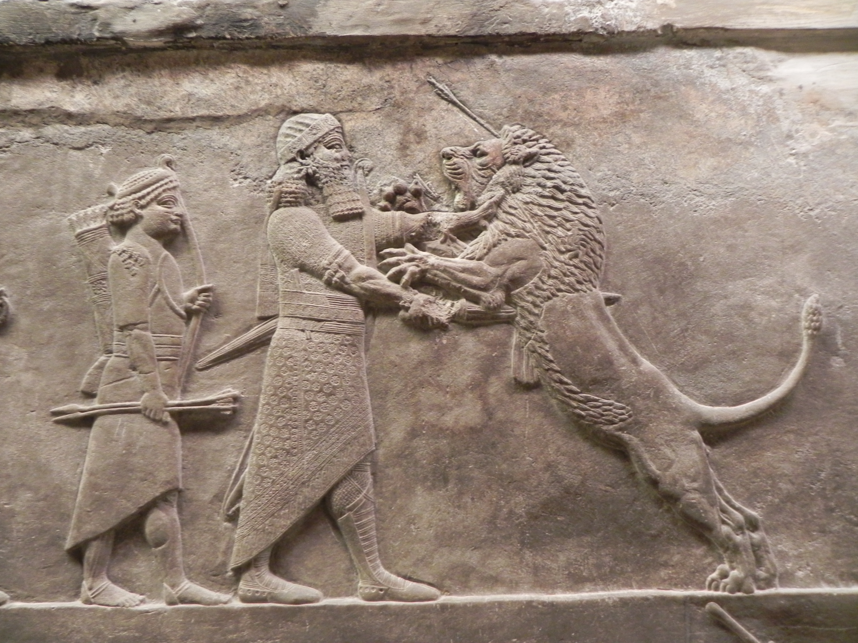

Late Assyrian Period, 1000-612 BCE, **formal bas relief (**645-635 BC**E) of** Assurbanipal (668– ca 627 BCE) killing a lion with a sword after having been first hit with an arrow into its forehead by the king’s attendant archer.

The effect is probably intended to be apotropaic, warning would-be enemies to be aware that Assyrian warriors were supremely dominant and to be feared more than lions. However, Assurbanipal **After the British Museum and see Frankfort 1988: 188, Fig. 211.**

**Sargon was almost certainly** the second ruler of the Semitic Akkadian Empire having been preceded by [Enshakushanna](https://en.wikipedia.org/wiki/Enshakushanna) (*lugal ki-en-gi ki-uri*, King of Sumer and Akkad) that signified kingship over Mesopotamia as a whole (Glassner 2000: 48). Sargon was known for his conquests of the Sumerian city-states during his reign (ca 2340 – ca 2284 BCE). During this period **the lion figure was depicted as an animal protective of the king and his people. The** "Sargonic Period" of Mesopotamian history lasted until the Guteans conquered

**References:**

Frankfort, Henri. 1988 [1970] *Art and Architecture of the Ancient Orient*. Penguin Books based on the 4th ed. London: Butler and Tanner co., Ltd.

Glassner, Jean-Jacques, 2000: Les petits etats Mésopotamiens à la fin du 4e et au cours du 3e millénaire. In: Hansen, Mogens Herman (ed.) *A Comparative Study of Thirty City-State Cultures*. Copenhagen: The Royal Danish Academy of Sciences and Letters,.

Reade, Julian. 1998. *Assyrian Sculpture*. 2nd edn. London: The British Museum Press.

|  |  |
| --- | --- |
| 1. ORDER DATEDec 11, 2016 | ORDER TOTAL  US $20.50  + US $5.00  shipping  **Order Old Wonderful Crystal intaglio Stone Near Eastern BEAD # L** [Leave feedback - ORDER DATE Dec 11, 2016](http://feedback.ebay.com/ws/eBayISAPI.dll?LeaveFeedbackShow&useridto=vintage.intaglio&transactID=0&item=282282020474&_trksid=p2057872.m2749.l2665)[View order details](http://payments.ebay.com/ws/eBayISAPI.dll?ViewPaymentStatus&transId=0&itemid=282282020474&_trksid=p2057872.m2749.l2673) - ORDER DATE Dec 11, 2016  [More actions - ORDER DATE Dec 11, 2016](http://www.ebay.com/myb/PurchaseHistory) |

1 item sold by [vintage.intaglio](http://www.ebay.com/usr/vintage.intaglio?_trksid=p2057872.m2749.l2754)

|  |  |  |
| --- | --- | --- |
| [Old Wonderful Crystal intaglio Stone Near Eastern BEAD # L](http://www.ebay.com/itm/282282020474?_trksid=p2057872.m2749.l2649&ssPageName=STRK%3AMEBIDX%3AIT)  ( 282282020474 )  Estimated delivery Fri, Dec 23 - Tue, Jan 10  Tracking number: [**Tracking number**809868302270](javascript:;)  [Add note](javascript:;) | ITEM PRICE:  US $20.50 |  |

|  |  |
| --- | --- |
| 2. ORDER DATEDec 11, 2016 | ORDER TOTAL  US $91.00  + US $6.00  shipping  **Order Antique Near eastern Men Hunter Animal intaglio Jastbar stone Bead** [Leave feedback - ORDER DATE Dec 11, 2016](http://feedback.ebay.com/ws/eBayISAPI.dll?LeaveFeedbackShow&useridto=silkroad.antique&transactID=0&item=162308238893&_trksid=p2057872.m2749.l2665)[View order details](http://payments.ebay.com/ws/eBayISAPI.dll?ViewPaymentStatus&transId=0&itemid=162308238893&_trksid=p2057872.m2749.l2673) - ORDER DATE Dec 11, 2016  [More actions - ORDER DATE Dec 11, 2016](http://www.ebay.com/myb/PurchaseHistory) |

1 item sold by [silkroad.antique](http://www.ebay.com/usr/silkroad.antique?_trksid=p2057872.m2749.l2754)

|  |  |  |  |  |  |  |  |
| --- | --- | --- | --- | --- | --- | --- | --- |
| [Antique Near eastern Men Hunter Animal intaglio Jastbar stone Bead](http://www.ebay.com/itm/162308238893?_trksid=p2057872.m2749.l2649&ssPageName=STRK%3AMEBIDX%3AIT)  ( 162308238893 )  Estimated delivery Tue, Dec 27 - Wed, Jan 11  [Add note](javascript:;) | | | | | | | ITEM PRICE:  US $91.00 |
|  | | [Wonderful Rare Old Bactrian Stone intaglio Seal Stamp bead](http://www.ebay.com/itm/162306923999?_trksid=p2057872.m2749.l2649&ssPageName=STRK%3AMEBIDX%3AIT)  ( 162306923999 )  Estimated delivery Tue, Dec 27 - Wed, Jan 11  [Add note](javascript:;) | | | ITEM PRICE:  US $69.00 |  | |
|  | ORDER DATEDec 09, 2016 | | ORDER TOTAL  US $55.00  + US $7.00  shipping  **Order Ancient Assyrian Stone Cylinder Seal.** [Leave feedback - ORDER DATE Dec 09, 2016](http://feedback.ebay.com/ws/eBayISAPI.dll?LeaveFeedbackShow&useridto=ram-11&transactID=1722822604002&item=122241422515&_trksid=p2057872.m2749.l2665)[View order details](http://payments.ebay.com/ws/eBayISAPI.dll?ViewPaymentStatus&transId=1722822604002&itemid=122241422515&_trksid=p2057872.m2749.l2673) - ORDER DATE Dec 09, 2016  [More actions - ORDER DATE Dec 09, 2016](http://www.ebay.com/myb/PurchaseHistory) |  | | | |

1 item sold by [ram-11](http://www.ebay.com/usr/ram-11?_trksid=p2057872.m2749.l2754)

|  |  |  |  |  |  |
| --- | --- | --- | --- | --- | --- |
| [Ancient Assyrian Stone Cylinder Seal.](http://www.ebay.com/itm/122241422515?_trksid=p2057872.m2749.l2649&ssPageName=STRK%3AMEBIDX%3AIT)  ( 122241422515 )  Estimated delivery Mon, Dec 19 - Thu, Dec 29  Tracking number: [**Tracking number**RT986155426DE](javascript:;)  [Add note](javascript:;) | | | | ITEM PRICE:  US $55.00 |  |
|  | ORDER DATEDec 08, 2016 | ORDER TOTAL  US $1,070.90  + US $17.95  shipping  **Order MAGNIFICENT RARE ANCIENT NEAR EASTERN CYLINDER SEAL, AGATE, 3000 BC,3000-5000BC MESOPOTAMIAN CYLINDER SEAL HEMATITE, ANCIENT,RARE AMBER 3000-5000BC MESOPOTAMIAN CYLINDER SEAL ANCIENT** [View order details - ORDER DATE Dec 08, 2016](http://payments.ebay.com/ws/eBayISAPI.dll?ViewPaymentStatus&transId=0&itemid=361841366480&_trksid=p2057872.m2749.l2673)[Contact seller](http://contact.ebay.com/ws/eBayISAPI.dll?ShowSellerFAQ&requested=estateconsignor&iid=361841366480&redirect=0&_trksid=p2057872.m2749.l2652) - ORDER DATE Dec 08, 2016  [More actions - ORDER DATE Dec 08, 2016](http://www.ebay.com/myb/PurchaseHistory) |  | | |

3 items sold by [estateconsignor](http://www.ebay.com/usr/estateconsignor?_trksid=p2057872.m2749.l2754)

|  |  |  |
| --- | --- | --- |
| [MAGNIFICENT RARE ANCIENT NEAR EASTERN CYLINDER SEAL, AGATE, 3000 BC](http://www.ebay.com/itm/361841366480?_trksid=p2057872.m2749.l2649&ssPageName=STRK%3AMEBIDX%3AIT)  ( 361841366480 )  Estimated delivery Thu, Dec 15 - Mon, Dec 19  [Add note](javascript:;) | ITEM PRICE:  US $457.00 | **Item MAGNIFICENT RARE ANCIENT NEAR EASTERN CYLINDER SEAL, AGATE, 3000 BC Orders 361841366480-0-0**[Leave feedback](http://feedback.ebay.com/ws/eBayISAPI.dll?LeaveFeedbackShow&useridto=estateconsignor&transactID=0&item=361841366480&_trksid=p2057872.m2749.l2665)[Return this item](http://postorder.ebay.com/Return/ReturnViewSelectedItem?transactionId=0&itemId=361841366480&_trksid=p2057872.m2749.l3185)  [More actions](http://www.ebay.com/myb/PurchaseHistory) |

|  |  |  |
| --- | --- | --- |
| [3000-5000BC MESOPOTAMIAN CYLINDER SEAL HEMATITE, ANCIENT](http://www.ebay.com/itm/361841366481?_trksid=p2057872.m2749.l2649&ssPageName=STRK%3AMEBIDX%3AIT)  ( 361841366481 )  Estimated delivery Thu, Dec 15 - Mon, Dec 19  [Add note](javascript:;) | ITEM PRICE:  US $297.00 | **Item 3000-5000BC MESOPOTAMIAN CYLINDER SEAL HEMATITE, ANCIENT Orders 361841366481-0-0**[Leave feedback](http://feedback.ebay.com/ws/eBayISAPI.dll?LeaveFeedbackShow&useridto=estateconsignor&transactID=0&item=361841366481&_trksid=p2057872.m2749.l2665)[Return this item](http://postorder.ebay.com/Return/ReturnViewSelectedItem?transactionId=0&itemId=361841366481&_trksid=p2057872.m2749.l3185)  [More actions](http://www.ebay.com/myb/PurchaseHistory) |

|  |  |  |
| --- | --- | --- |
| [RARE AMBER 3000-5000BC MESOPOTAMIAN CYLINDER SEAL ANCIENT](http://www.ebay.com/itm/361841366484?_trksid=p2057872.m2749.l2649&ssPageName=STRK%3AMEBIDX%3AIT)  ( 361841366484 )  Estimated delivery Thu, Dec 15 - Mon, Dec 19  [Add note](javascript:;) | ITEM PRICE:  US $316.90 | **Item RARE AMBER 3000-5000BC MESOPOTAMIAN CYLINDER SEAL ANCIENT Orders 361841366484-0-0**[Leave feedback](http://feedback.ebay.com/ws/eBayISAPI.dll?LeaveFeedbackShow&useridto=estateconsignor&transactID=0&item=361841366484&_trksid=p2057872.m2749.l2665)[Return this item](http://postorder.ebay.com/Return/ReturnViewSelectedItem?transactionId=0&itemId=361841366484&_trksid=p2057872.m2749.l3185)  [More act](http://www.ebay.com/myb/PurchaseHistory) |